Troubleshooting guide on creating the Active Workspace Client war file if you are behind a proxy server

This documents will give you some input what to check if you want to create a war file for Active Workspace Client and your internet connection is setup with a proxy server. This will **not** cover all possible issues. All depends also on the used proxy server and on the security rules set on the proxy server.

Contents

1 Basic Use Case 3

2 Internet connection check 3

3 Troubleshooting steps 4

3.1 Step 1 4

3.2 Step 2 4

3.3 Step 3 5

4 Conclusion 6

# Basic Use Case

Due the need of an internet connection while creating the war file for Active Workspace you can run into some issues which are related due the use of a proxy server in your network.

The problem starts with the ”**gwtcompile.cmd' has returned with status: '1'** “ while you create the Active Workspace Client war file.

# Internet connection check

Assumption is that the server has internet access. For example just check a site in the browser which must be allowed to access.

The process of creating the war file needs access to following sites:

<http://maven.apache.org>  
<http://repo1.maven.org/maven>  
<https://github.com2>

During the troubleshooting those sites were not set in the proxy server settings. The sites above where found during the troubleshooting steps in the next section.

# Troubleshooting steps

## Step 1

Maven needs access to the internet during creation of the Active Workspace war file. To check the used proxy settings in the browser for example Internet Explorer to find the settings. Unfortunately it could be configured using a configuration script, then you need to find out what the settings are by checking the local IT department.  
If it is set manual the address of the proxy server is e.g. <http://awproxy:8888>

Edit the settings.xml in the %TC_ROOT%\aws2\stage\ add the proxy configuration:

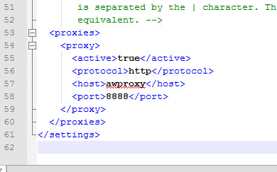

## Step 2

If the next try still gives **gwtcompile.cmd' has returned with status: '1'** please verify the following: Maven doesn’t support NTLM proxies, so the next step is to change following line in the gwtcompile.bat:

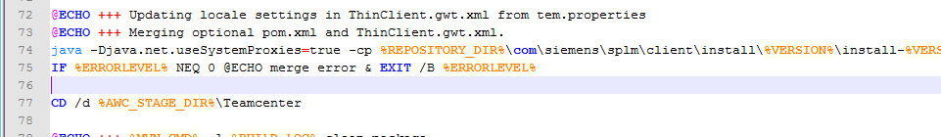  
  
At line 74 I added –Djava.net.useSystemProxies=true, another option is to use -Dhttp.proxyHost=<IP of proxy server> -Dhttp.proxyPort=<proxy port>

## Step 3

If the next try still give **gwtcompile.cmd' has returned with status: '1'** verify the following. Analyze the log file and this will point to an error related to the thinclient.gwt.xml and special:  
  
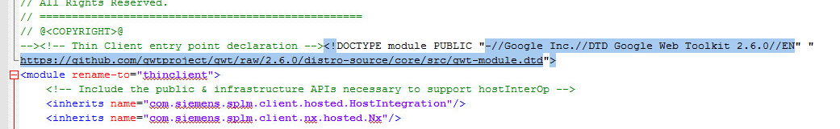

Add the <https://github.com> site to the sites which can be accessed through the proxy, this are settings made in the proxy configuration.

In the IExplorer try to access following URL and check if it is working:  
<https://github.com/gwtproject/gwt/raw/2.6.0/distro-source/core/src/gwt-module.dtd>.   
  
If you get a security certificate message, install the security certificate in the web browser and verify if you can open this file without the certificate warning.

Export the certificate from the browser into a github.cer file and imported the github.cer into the Java cacert file of the java installation used by tem.bat.

NOTE: could be possible to import a certificate for the proxy server software itself, but that depends on the type of the proxy and how the proxy is configured.

On the used proxy server also added following sites to be allowed to access through the proxy server (see settings.xml)  
<http://maven.apache.org>  
<http://repo1.maven.org/maven2>

# Conclusion

It is still possible that it will not work and that will be related to the proxy configuration itself which depends on the used proxy server. If it doesn’t work you have the possibility to create the war file on a separate machine which has access to internet without a proxy configured. See for details the Active Workspace deployment guide, section “Install the Active Workspace patch on the WAR file build host”.

Dave Janssen