Using a license options file

A license options file can be used to manage and control the use of the license features in your license file, for instance to allow or deny the use of features and reserve licenses.

The options file can be created using a text editor. It is recommended to save the file in the same location as the license file, but it can be saved anywhere.
The path to the options file needs to be specified on the VENDOR line in the license file by entering the path to the file. For example:

SERVER YourHostname COMPOSITE=123456ABCDEF 28000
VENDOR ugslmd options="C:\Program Files\Siemens\PLMLicenseServer\optionsfile.opt"

You can also save the options file as ‘ugslmd.opt’ in the same location as the license file. The vendor daemon ugslmd will automatically pick up the options file. In this case it will not need to be specified in the license file.

In your license debug log file the options file being used will be shown as:
Using options file: "C:\Program Files\Siemens\PLMLicenseServer\ugslmd.opt"

In the options file the use of license features can be restricted. This can be done for users, computers and groups. By default the group case insensitivity is turned off, meaning the names of users and computers are case sensitive.
To make the names case insensitive set the following in the options file:
GROUPCASEINSENSITIVE ON

To restrict the license use for groups, the groups must first be defined.
Groups can be created based on user names, computer names or IP addresses.

To create a group CAD_USERS with users Thomas and Anne:
GROUP CAD_USERS Thomas Anne
USER_GROUP can also be used instead of GROUP.
The usernames may not contain spaces.

To create a group CAM_USERS for the computers camsystem1 and camsystem2:
HOST_GROUP CAM_USERS camsystem1 camsystem2
When creating a group for computers, you can also use IP Addresses instead of the computer names. The IP Addresses may contain wildcards:
HOST_GROUP CAM_USERS camsystem1 camsystem2 123.123.*.*
This will create a group CAM_USERS for computers camsystem1, camsystem2 and all computers with an IP Address starting with 123.123.

License bundles and features can be included, excluded and reserved for users, hosts and groups.
To exclude the feature gateway:
EXCLUDE gateway USER Thomas excludes user Thomas to use the gateway
EXCLUDE gateway HOST camsystem1 excludes computer camsystem1 to use the gateway
EXCLUDE gateway GROUP CAD_USERS excludes user group CAD_USERS to use the gateway
EXCLUDE gateway HOST_GROUP CAM_USERS excludes host group CAM_USERS to use the gateway
EXCLUDE gateway INTERNET 123.*.*.* excludes all computer with IP address starting with 123
to use the gateway
EXCLUDE gateway DISPLAY camsystem10.0 excludes display camsystem10.0 to use the gateway
EXCLUDE gateway PROJECT CAM excludes any user with an environment variable
LM_PROJECT set to CAM to use the gateway

Once the license server has been started the license debug log will show:

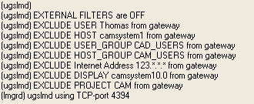

To exclude all bundles and features the option EXCLUDEALL can be used.
For instance for the user Thomas:
EXCLUDEALL USER Thomas

When a user on an exclude list tries to start NX, one of the following messages will be shown, depending on the NX version being started:

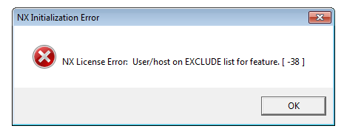

For NX 8.5:

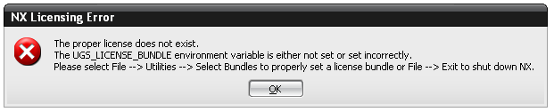

For NX 7.5:

When using the option INCLUDE, the specified user will be allowed to use this feature. Any other user not in the INCLUDE or INCLUDEALL list will not be allowed to use this feature.
If there is a conflict between the EXCLUDE and INCLUDE list, the EXCLUDE will take precedence.

INCLUDE gateway USER Thomas
This means that user Thomas will be allowed to use the feature gateway. If this is the only INCLUDE, all other users will not be allowed to use the feature gateway.
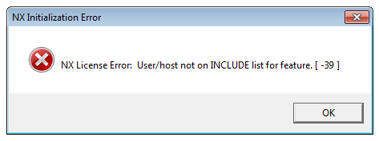
If a user not in the include list tries
to start NX the following message
will be displayed:

There will be a conflict between the INCLUDE and EXCLUDE if USER Thomas tries to check out the license feature gateway on computer camsystem1:
HOST_GROUP CAM_USERS camsystem1 camsystem2
INCLUDE gateway USER Thomas
EXCLUDE gateway HOST_GROUP CAM_USERS

The gateway is included for Thomas, but it is excluded for the HOST_GROUP CAM_USERS.
The EXCLUDE will take precedence and Thomas will not be allowed to check out the feature.
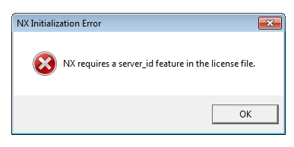
When using INCLUDEALL, a user not in
the include list will not be allowed to
check out any license feature. Starting
NX the following message will be shown:

The option RESERVE can be used to reserve a specified number of features for a specific user, computer, group or project. To reserve 15 gateway features for the project CAM:
RESERVE 15 gateway PROJECT CAM

With the option MAX a maximum number of license features can be specified for a user, computer, group or project. To limit the usage of the feature gateway to a maximum of 3 for the group CAD_USERS:
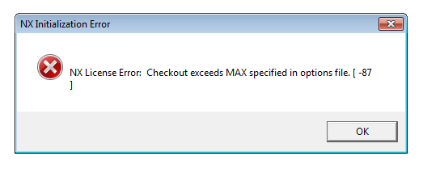
MAX 3 gateway GROUP CAD_USERS

When a 4th user of the group CAD_USERS
tries to check out the gateway feature the
following message will be displayed in NX8.5:

When the Borrowing option has been included in the license file it is also possible to include or exclude users, groups etc from borrowing specific features.
To do this the options INCLUDE_BORROW and EXCLUDE_BORROW can be used.
These options work the same way as the INCLUDE and EXCLUDE options, when there is a conflict the EXCLUDE_BORROW will take precedence.
INCLUDE_BORROW gateway USER Thomas
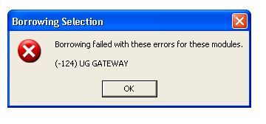
This will allow user Thomas to borrow the gateway feature. All other users not in the include list will not be allowed to borrow the gateway.
When borrowing fails because the user is
not in the INCLUDE list, or because the user
is in the EXCLUDE list, the following message
will be displayed:

The options EXCLUDE, EXCLUDEALL, INCLUDE, INCLUDEALL, RESERVE, MAX, EXCLUDE_BORROW and INCLUDE_BORROW can be used for the types: USER, HOST, DISPLAY, PROJECT, GROUP, HOST_GROUP.

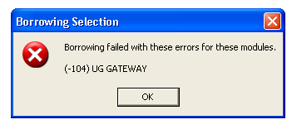
With the borrow option in the license file the default maximum period a license can be borrowed is set to 2880 hours (120 days). It is possible to reduce the maximum period a feature can be borrowed by setting the MAX_BORROW_HOURS. For instance to reduce the maximum period the feature gateway can be borrowed to 1 week (168 hours):
MAX_BORROW_HOURS gateway 168

If a user tries to borrow the feature
gateway for a period longer than
the MAX_BORROW_HOURS the
following message will be displayed:

If you do not want your users to borrow all the licenses in the license file the BORROW_LOWWATER can be set. BORROW_LOWWATER sets the number of license features that cannot be borrowed.
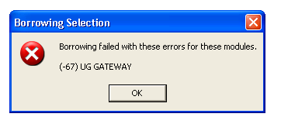
For instance with 15 gateways in the license file, only 10 should be allowed to be borrowed and 5 gateway features should not be borrowed:
BORROW_LOWWATER gateway 5

If a user tries to borrow beyond the limitation
this message will be shown:

NOLOG can be used to suppress messages in the debug log file. It can be set to IN to suppress check in messages, and OUT to suppress checkouts, DENIED to suppress the DENIED messages or UNSUPPORTED to suppress the unsupported messages. Only one setting can be used per line, if you want to suppress multiple messages in the debug log file you will need to create a NOLOG line for each entry:
NOLOG IN
NOLOG OUT
Reducing messages will decrease the size of the debug log file. However, when debugging license issues the debug log file will be less useful.

DEBUGLOG can be used to specify a file for the debug log.
DEBUGLOG +"C:\Program Files\Siemens\PLMLicenseServer\debuglog.txt"
The + character can be used to keep Windows from overwriting the file each time the license server is started.
When there are spaces in the path, the path should be enclosed with double quotes.

Lines starting with a # character will not be read and can be used for comments.

Emiel Verhoeven

