Formulation of Conditional Expressions
It may be necessary to base the value of multiple expressions upon the values of multiple input variables. When there are multiple requirements that determine the value of an expression, the formula will need conditional statements.
In a simple example, the extrude height of three bosses is based off the length and width dimensions of the plate.
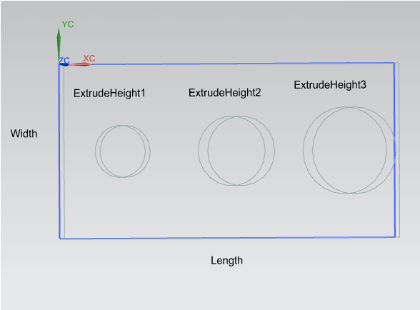
In this part, the input variables are the ‘Length’ and ‘Width’ dimensions that define the length and width of the plate. Currently, ‘Length=20’ and ‘Width=10’.
This part also has three expressions, each defining the height of an Extrude.
- ExtrudeHeight1 is the Extrude height of the first boss.
- ExtrudeHeight2 is the Extrude height of the second boss.
- ExtrudeHeight3 is the Extrude height of the third boss.

Whether the ‘Length’ and ‘Width’ values are maintained, determines the Extrude height for each of the bosses. Below is a table of the possible combinations.
Length = 20 | Width = 10 | ExtrudeHeight1 | ExtrudeHeight2 | ExtrudeHeight3
True | True | 1 | 2 | 2
False | True | 1 | 1 | 2
True | False | 2 | 1 | 1
False | False | 2 | 2 | 1
For example, in the first row of this table, if both the ‘Length’ and ‘Width’ dimension values are maintained and ‘Length=20’ is True and ‘Width=10’ is True, then ‘ExtrudeHeight1=1’, ‘ExtrudeHeight2=2’ and ‘ExtrudeHeight3=2’.
Since each ExtrudeHeight only has a value of “1” or “2”, an expression can be created for each condition of the Extrude value.
Name of Expression | Formula
ExtrudeHeight1 | if ((length != 20 && width != 10) || (length == 20 && width != 10)) (2) else (1)
which means: | if ((length≠20 AND width≠10) OR (length=20 AND width≠10)) = 2 else = 1
simplified: | if ((false AND false) OR (true AND false)) = 2 else = 1
ExtrudeHeight2 | if ((length == 20 && width == 10) || (length != 20 && width != 10)) (2) else (1)
which means: | if ((length=20 AND width=10) OR (length≠20 AND width≠10)) = 2 else = 1
simplified: | if ((true AND true) OR (false AND false)) = 2 else = 1
ExtrudeHeight3 | if ((length == 20 && width == 10) || (length != 20 && width == 10)) (2) else (1)
which means: | if ((length=20 AND width=10) OR (length≠20 AND width=10)) = 2 else = 1
simplified: | if ((true AND true) OR (false AND true)) = 2 else = 1
In the formulas, each ExtrudeHeight was given the conditions where it equals the value “2”; otherwise it equals “1”.

To better explain this, for ExtrudeHeight2, if both the ‘Length’ and ‘Width’ dimension values are maintained (‘Length=20’ and ‘Width=10’), OR neither the ‘Length’ or ‘Width’ dimension values are maintained (‘Length≠20’ and ‘Width≠10’), then ‘ExtrudeHeight2=2’; otherwise, ‘ExtrudeHeight2=1’.

There are several operators that can be used in expression formulas. Not all of them were used in the above example, so here is a list.
Operator | Function
+ | Addition
- | Subtraction and Negative Sign
* | Multiplication
/ | Division
% | Modulus
^ | Exponential
= | Assignment
Operator | Function
> | Greater Than
< | Less Than
>= | Greater Than or Equal
<= | Less Than or Equal
== | Equal
!= | Not Equal
! | Negate
& or && | Logical AND
| or || | Logical OR

The possibilities are endless and each situation is unique, but hopefully this example and list of operators can be referenced as a starting point for creating “real world” conditional expressions that are based upon multiple input values.
Angie Deering

