Adding a custom ribbon tab per application using file based customization
Let’s say that we want to use our own ribbon tab in Modeling and Manufacturing using file based customization. First of all set the environment variable UGII_USER_DIR, for example:
UGII_USER_DIR=C:\NX9
This can be done in …\NX 9.0\UGII\ugii_env.dat.
Create the “application” and “startup” folders in the user directory. Then create the “profiles” structure under application like below.
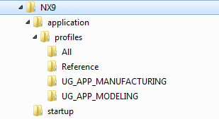
Put the files that your ribbon tab will use (toolbars, groups, galleries etc.) in the startup folder. They will then be available as soon as NX starts.
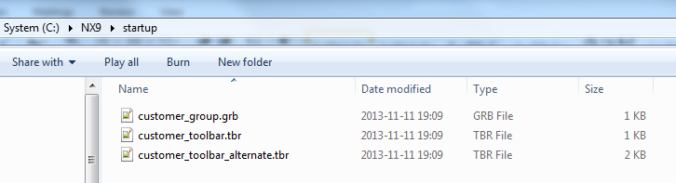
Put the ribbon tab file in the application\profiles\Reference folder. This makes it available for all applications.
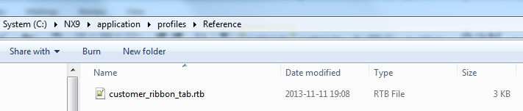
Copy …\NX 9.0\UGII\menus\profiles\UG_APP_MODELING\UG_APP_MODELING.dtx to the application\profiles\UG_APP_MODELING folder.
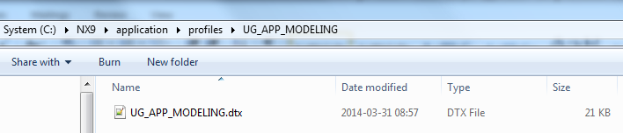
Edit the file and add the following highlighted statement.
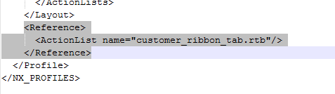
Copy …\NX 9.0\UGII\menus\profiles\UG_APP_MANUFACTURING\UG_APP_MANUFACTURING.dtx to the application\profiles\UG_APP_MANUFACTURING folder.
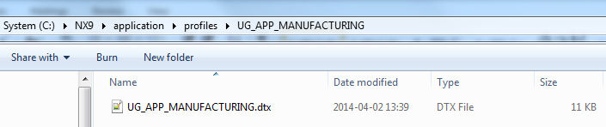
Edit the file and add the following highlighted statement.
Start NX 9 and create a new Model. Notice that the ribbon tab is visible in Modeling.
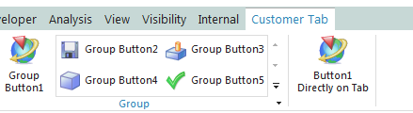
Switch to Manufacturing and notice that the tab is still visible. Switch to drafting and the tab is not available.

Mathias Maathz
GTAC EMEA

