Solr Indexing for the Reuse library on server and clients

This document describes how to setup Solr indexing from the documentation server, so that it can be used to search the NX reuse library.

## Step 1: Setting up the Siemens PLM documentation server

Setting up the Documentation server, as described in the documentation provided with the Siemens PLM Documentation Server. The latest version can be found and downloaded from our Download server:

<https://download.industrysoftware.automation.siemens.com/> 🡪 Siemens PLM Documentation Server

For the Documentation server version 2.0 and later please note the following:

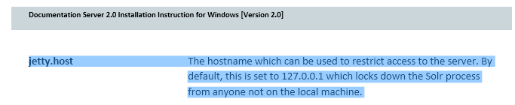

Note there is a difference in port depending on the (initial) documentation server that has been installed.

* 1. TDOC server 1.0 uses 8181 port as default for solr server
     1. This also applies if you upgrade (not reinstall) version 1.0 to a later version.
  2. TDOC server 2.0 and later, uses 8283 port as default for solr server

Due to security reasons we have changed a registry setting in the Doc server version 2.0 and later.

Please use caution solving this issue. First of all you need to edit the registry. Be sure you know what you are doing and create a backup of your registry first.   
Secondly, changing the settings, might harm your security.

We have protected the Solr server because it has a security flaw that allows open access to it, which potentially enables access to the management console.

If you want to open it up, you take on the risk and then must change the registry.

*HKLM\SOFTWARE\Wow6432Node\Apache Software Foundation\Procrun 2.0\Siemens PLM Solr Server\Parameters\Java*

Edit the “*Options”* parameter and change

*-Djetty.host=127.0.0.1* to

-*Djetty.host=0.0.0.0* and restart the service

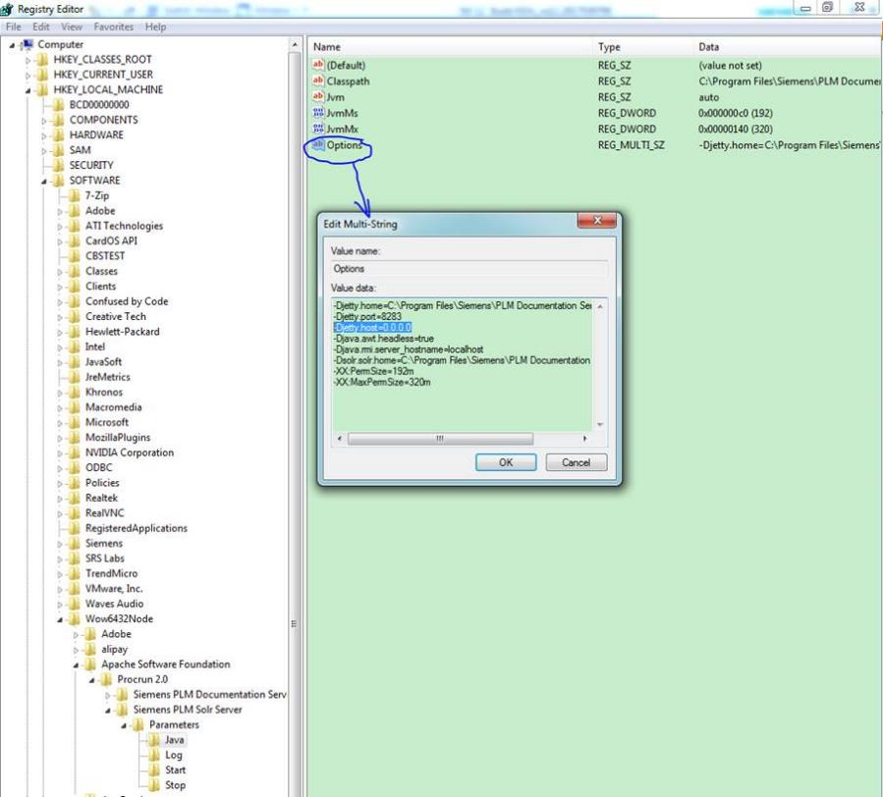

## Step 2: Setting up the indexing in the NX Customer defaults on the server

Specify Index Search server, in the NX customer defaults: File 🡪 Utilities 🡪 Customer Defaults 🡪 Gateway 🡪 Reuse Library 🡪 tab: Index Search

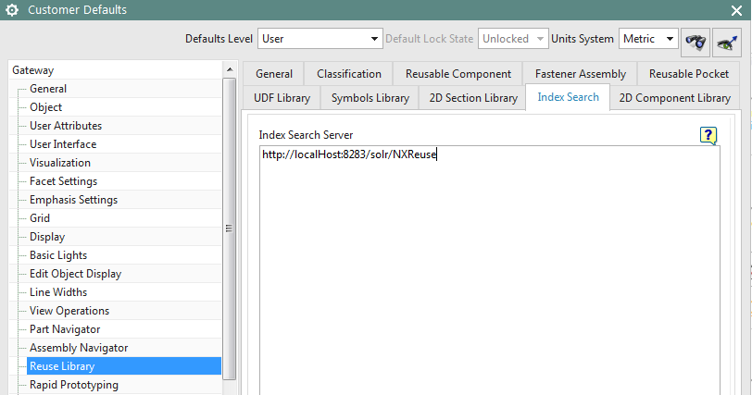

Please check the Documentation Server port, and update it to index search customer defaults.

For example, the installation port is 8283, and you can use:

<http://localhost:8283/solr/NXReuse>

Don’t forget to restart NX to enforce the customer default settings.

To check if solr is up and running on the correct port, you can visit the page in a browser: (please note the /#/ in the URL, which is needed for it to work in a browser, not in the Customer Default setting)

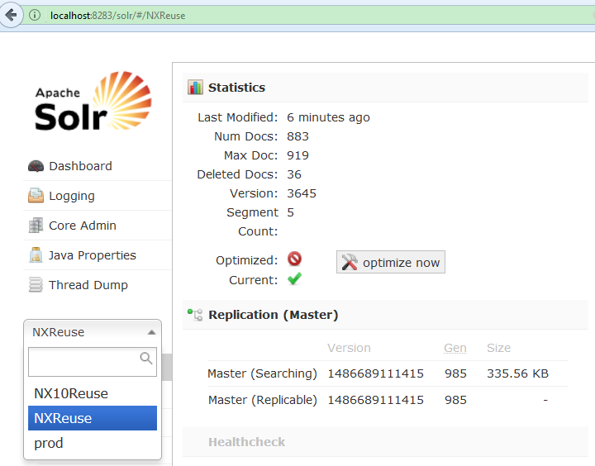

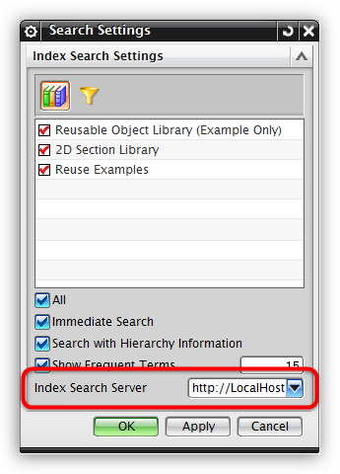You can specify several servers in customer defaults, and select the current server from index search settings:

## Step 3: Create Index search

In NX, right click on an empty space in the Reuse Library, and select “Library Management”

1. Turn on the Settings:

* Create Index for Part Attributes.
* Create Index for Part Expressions.
* If index search is off, or no index search service is available, the setting group will be invisible.

1. For one library:

* Select one library which we want to index.
* Click the “Create Index” button at the top to create the index.

1. For multiple libraries:

* Select one library and MB3 🡪 Send to Index Builder (an exclamation mark will appear in the index column).
* Do this for all the other libraries you want to index, send them one by one.
* 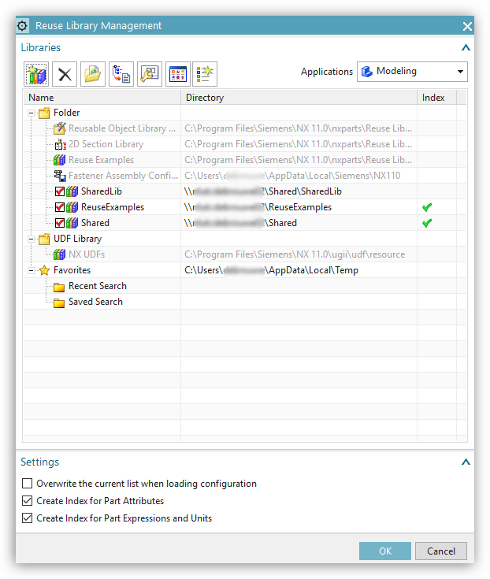When all are selected, click the “Create Index” button to create the index for all libraries.

Once indexed, a green check mark will appear behind the library.

## Step 4: Setting up the Client side

On all clients, set the Reuse index to the central server in the customer defaults:

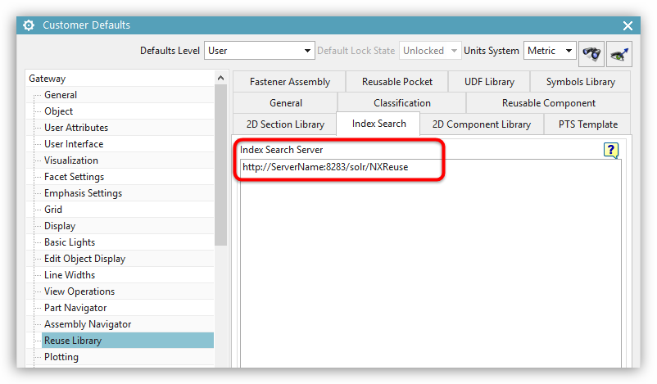

Where “ServerName” should state the Name of the server that is running the actual indexer (the machine used in the first two steps).

## Step 5: Update Index Search

1. For manually updating the index data:

* If user edited or added to the library folder structure at the operating system level you need to manual update the index data.

For example, if new parts were added to the library, a part or folder was renamed, or a part has been changed.

* Select the indexed library and click “create index”. This will show the following message:

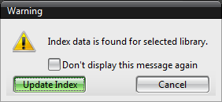

* Click “Update Index”. Newly modified data will be indexed, and be searchable after the update.

1. For automatic update the index data

* If a user modifies something in the reuse library navigator or reuse library management, it will immediately update the index data.

For example, renaming the library folder, defining a reuse object, or defining a symbol in reuse library navigator.

## Step 6: Delete Index Search

1. Delete Index

* Tool 🡪 Reuse Library 🡪 Reuse Library Management (or MB3 in reuse library navigator and select Reuse Library Management)
* Right click on an indexed library and select “Delete Index”

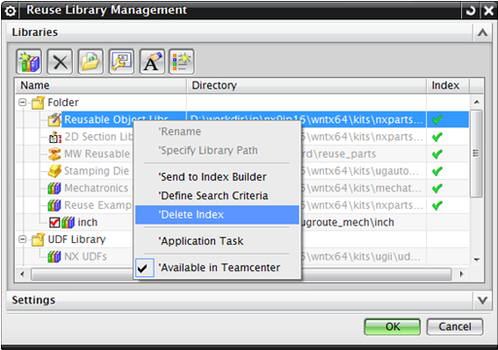

1. Remove library:

* Tool 🡪 Reuse Library 🡪 Reuse Library Management (or MB3 in reuse library navigator and select Reuse Library Management).
* Select an indexed library and click the “remove library”, will remove the library and delete the index data.

1. Delete the local cached index data:

* Go to the Index Data Location, the default is “$UGII_TMP_DIR\ReuseLibraryCache\SearchData”
* Delete the folder “SearchData”, all index data will be delete.

## Step 7: Index Search Settings

1. In the Reuse library navigator under the “search” group click: 
2. In Search Settings dialog:

* Filter the library: If you didn’t select the library to search, it will use the filter library to search.
* Filter the type: it will always filter the result after search.
* Immediate Search: If the option is ON, it will perform the search immediately while the user selects the “frequent term”.
* Search with Hierarchy Information: If the option is ON, if you search a folder, it will display all the standard parts in the folder which we search.
* Show Frequent Terms: If the option is ON, it will show frequently searched terms after you type some key words. You can control the number of shown options. The value must be greater than or equal to 1.
* Index Search Server: User can switch the service in the session.

On the first start, it will test all the services from customer defaults until it finds a valid one, and set it as the current service. Once the user changes the service in the search settings dialog, it will be remembered in the registry. When NX is restarted, it will be checked first if it exists in the customer defaults.

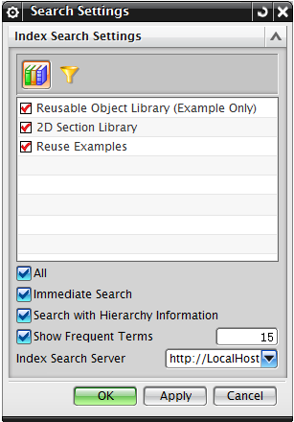

1. Search pull-down menu:

* In Reuse Library Navigator 🡪 Search dialog, there is a pull-down menu in the left of the search dialog.
* It will list the search fields. Select the search field from the pull-down menu as shown below, the default is “Descriptive Name”

Native:

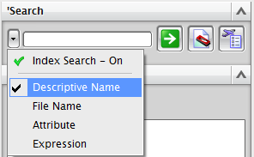

NX/ Manager:

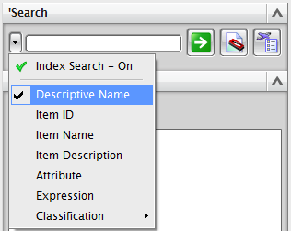

* Pull-down menu is disabled if there is a dialog on.

## How to use the Search 1: Basic Index Search

* Go to Reuse Library 🡪 Pull down the Search box 🡪 Descriptive Name (File Name).
* Select an indexed library or folder, or not select but search all the indexed libraries.
* In the string input box, press the down arrow key. This will show frequent searched items. You can press again the down arrow button to select an existing entry or you can directly input some query word.

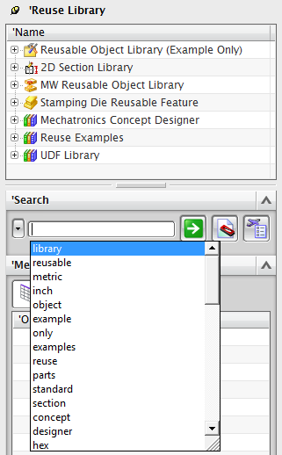

* For example, if you query an “s”, it will auto-complete the first query word, or we can press the up/down arrow key to select the string and press Enter, or use the mouse to select.

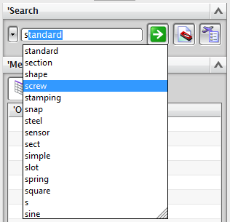

* If you select “screw” and type a space, the field will show a new auto-complete list, and the existed string will not be displayed in the frequently used items.
* To filter the search result, we support keywords like: “in”, “type”, “itemId”, “itemDesc”, “itemId”, “name”, “fileName”, “level”, “attr”.

They are case-insensitive.

For example, after selecting the “screw”, enter the string “type:”, and it will show an auto-complete list to show all types. Select a type to filter.

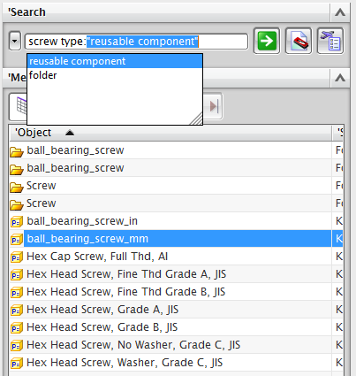

* Press Enter, and it will show all results containing “screw” and where the type is “reusable component”.

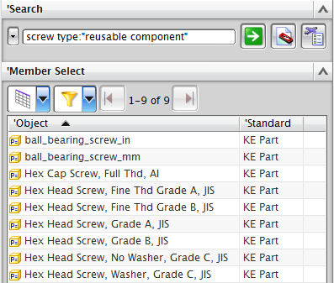

## How to use the Search 2: Attribute and Expression Search

* Go to Reuse Library 🡪 Pull down the Search box 🡪 Attribute (or Expression).
* If you input the following query “attribute”, it will create a column and list all values.

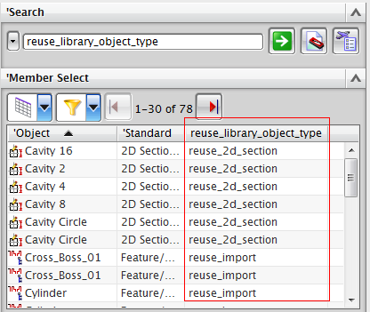

* “Object” and “Standard” column width will be remembered in the registry. It works even if we restart NX. And other columns will be remembered in the current session. Turn page will show the attribute too.
* We can also search attributes by condition: “=”, “==”, “>”, “<”, “>=”, “<=”

String type attributes only support “=”, Number type attributes support all options.

For example, input “reuse_library_object_type=”, it will show all values for this attribute.

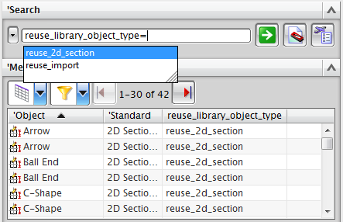

For the expression, input “length>=50.0”, it will show all length values equal or greater than 50.

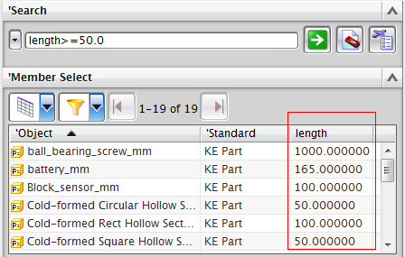

* It also supports two or more attribute searches at the same time.

For example, Input “length>=10 diameter<25”, it will show all length values equal or greater than 10 and diameter less than 25.

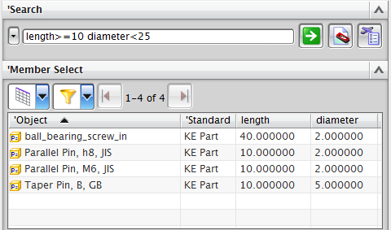

# How to use the Search 3: Hierarchy information search

* Go to the Reuse Library 🡪 Pull down the Search box 🡪 Descriptive Name.
* Make sure the “Search with Hierarchy Information” is turned on.
* Select the library “MW Standard Part Library” and search “dme”, it will display the folder containing “dme”, also display all parts from the folder.

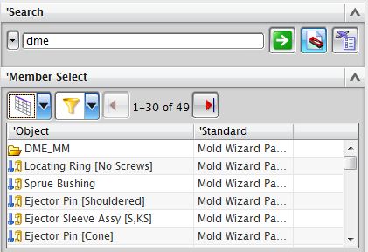

## How to use the Search 4: Advanced Index Search

1. Advanced Search Syntax:“AND”, “OR”, “NOT”, “Grouping”

* Syntax “AND”, same for use space or “&&”.

For example, type the query word in the input box: “Screw AND Hex ” or “Screw && Hex” or “Screw Hex”. It will search the terms that contains "Screw” and "Hex"

* Syntax “OR”, same for use “||”.

For example, type the query word in the input box: “inch OR ai” or “inch||ai”. It will search the terms that contains either "inch" or “ai”

* Syntax “NOT”, same for use “!”.

For example, type the query word in the input box: “Hex NOT DIN” or “Hex !DIN”. It will search the terms that must contain "Hex" but not "DIN"

* Grouping search

For example, type the query word in the input box: “(GB NOT DIN) OR screw” or “(GB !DIN) || screw”. It will search the terms that must contain "GB" but not "DIN" or contain “screw”.

1. Define Search Criteria

* Reuse Library Management 🡪 MB3 an indexed library 🡪 Define Search Criteria

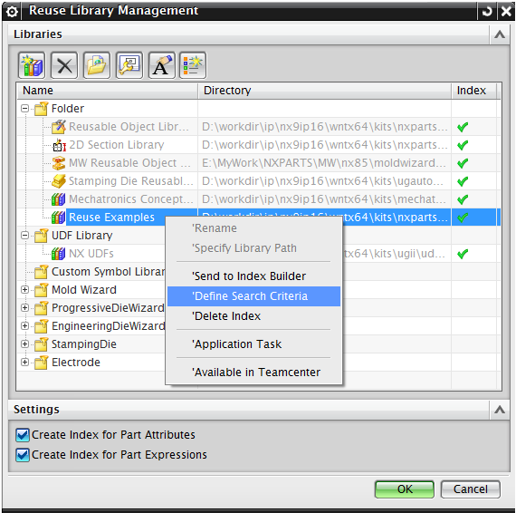

* In the Define Search Criteria dialog

Define attribute:

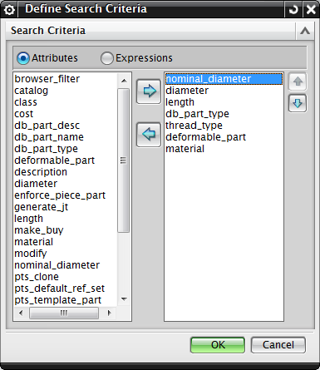

Define expressions:

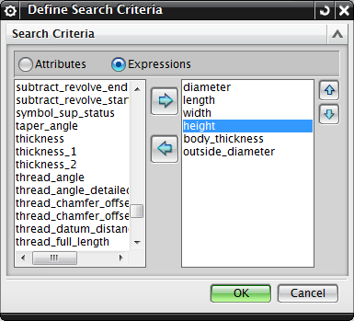

1. Search Nodes Below Here

* Reuse Library Navigator 🡪 Reuse Example 🡪 MB3 🡪 “Search Nodes Below Here…”

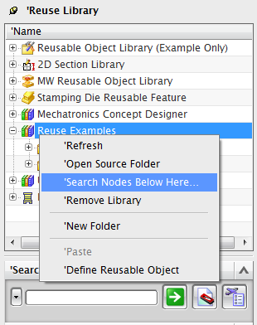

* It will show an Index Search dialog:

“(S)” means this attribute (or expression) is of type String

“(N)” means this attribute (or expression) is of type Number

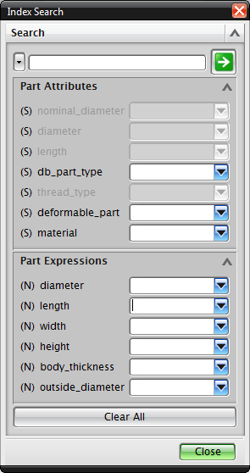

* This dialog is always open until the user closes it or the application is changed.

So you can use the search result, or other functions, even if the dialog is open.

This is a special dialog, it’s the same as “Journal Editor” or “Command Finder” dialog.

* The dialogue will be reopened if the user clicks “Search below here” for another library.
* We can use the operator for the attributes or expressions.

Such search key work “plain”, and attribute material is “steel”, expression diameter is more than 5 less than 20.

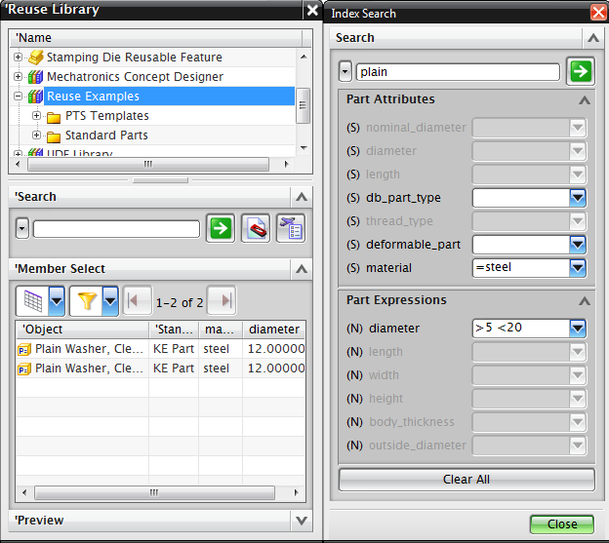

* After the attribute or expression search, you can sort the values by clicking the column.

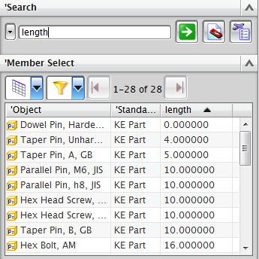

## How to use the Search 5: Miscellaneous

1. Search on the name of a part or folder, for example “nut”  
   name: nut  
   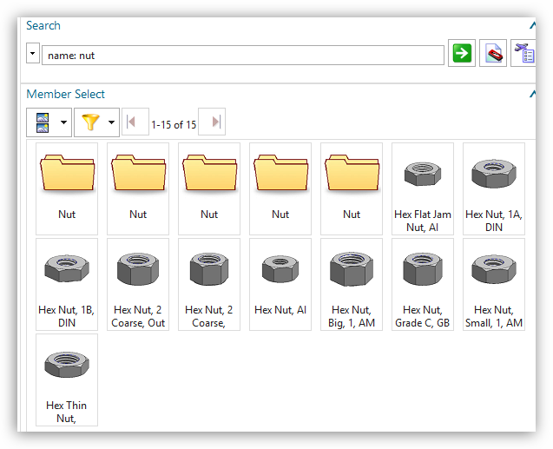
2. If the string contains a “-” or “_”, this will transform to space when you do the indexing.

For example, “Side_Lock_Sets” will transform to “Side”, “Lock”, “Sets”.

This behavior works for tooling standard parts only. An attribute will not transform.

1. If there is “and”, “or” from the frequent item will be remove.

For example, search the “ESNP-(Straight Ejector Sleeve and Straight Center Pin Sets)”

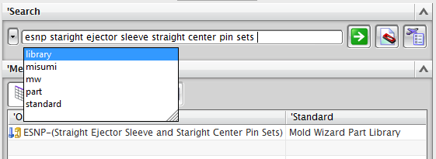

1. Support ITI

The string “中文” will be indexed as “中” and “文”

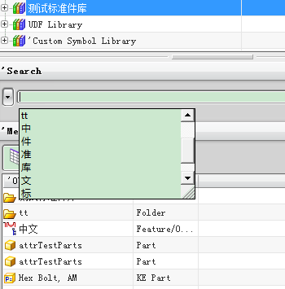

Dennis de Brouwer