Setup SOL 111 Modal Frequency Analysis to Match NX Response Simulation

NX Advanced Simulation has to ability to solve a modal frequency response analysis, using NX Nastran or with the NX Response Simulation product. To be able to run the SOL 111 Modal Frequency Response analysis, an add-on NX Nastran Dynamic Response license is needed. Response Simulation is an add-on product to Advanced Simulation that uses the NX Nastran SOL 103 Normal Modes Solution that includes extra data. The Solution is titled SOL 103 Response Simulation. The two Solutions can be compared but attention should be paid to what input data is needed for each analysis, so that the two sets of results are comparable.

NX Nastran SOL 111 is a modal frequency response analysis that uses results from a SOL 103 – Normal Modes analysis to calculate the response of a structure in the frequency domain. Response Simulation is an interactive module, inside NX Advanced Simulation that uses results from a specialized SOL 103 – Normal Modes analysis to calculate several types of structural response analyses. Though both solutions can be comparable, the workflow and User Interface within NX Advanced Simulation is somewhat different.

Although it is possible to get results that are comparable between the solutions the following should be taken into account when setting up each model, for comparison. Recommended extra reading is available in the NX Online Help section:
CAE → Advanced Simulation → Response Simulation → Response Simulation Workflow.

Recommended extra reading to supplement the following see:
CAE→Advanced Simulation→ Command Reference → New Event Dialog.

Try to get the excitation frequencies to be the same. This would primarily involve adjusting the abscissa spacing (ie. frequency), additional frequencies to increase resolution of the result, interpolation method and the data recovery method. The abscissa spacing for frequency and random response, in Response Simulation can be set to even or uneven. If the functions, in Response Simulation, are evenly spaced, the response is calculated at the input frequencies only. If the functions are unevenly spaced, the response is calculated at the input frequencies, the natural frequencies, and at additional spectral lines in between. SOL 111 usually has an even spacing.

One of the Response Simulation options for Frequency or Random Response is “additional spectral lines”. This is only available for frequency and random response events when the spacing is set to Uneven. Thus the results will be generated at the excitation points, Normal Mode Frequencies, and at the Additional Spectral Lines in between. The closest function within NX Nastran SOL 111, to additional spectral lines is the FREQ, FREQ1-FREQ5 cards. Each FREQ(i) card uses a different approach to determine the extra frequencies to in the response calculation.

The Interpolation Method in Response Simulation is available only for frequency and Random event when the spacing is set to uneven. The following methods are selectable for the software to approximate data points when generating the response functions with the additional spectral lines: Log-Log, Linear-Linear, Linear-Log and Log-Linear. The closest option SOL 111 uses is the FREQ3 card, which defines the number of excitation frequencies used between modal pairs in a given range. The input has a lower and upper bound, number of excitation frequencies within each sub-range and a cluster value that provides closer spacing of excitation frequencies near the modal frequencies. The Type field, on the FREQ3 card, specifies whether linear or logarithmic interpolation is done between frequencies.
The Data Recovery Method in Response Simulation can be selected when a new frequency or transient event is created. It can be either Mode Displacement or Mode Acceleration. SOL 111 has Mode Displacement as the default for PARAMETER MODACC. Param, MODACC, -1 (ie. the default) invokes Mode Displacement Recovery method and PARAM, MODACC,0 invokes the Mode Acceleration Recovery method.

NX Nastran SOL 111 | NX Response Simulation
Solution dialog for SOL 111 Modal Frequency  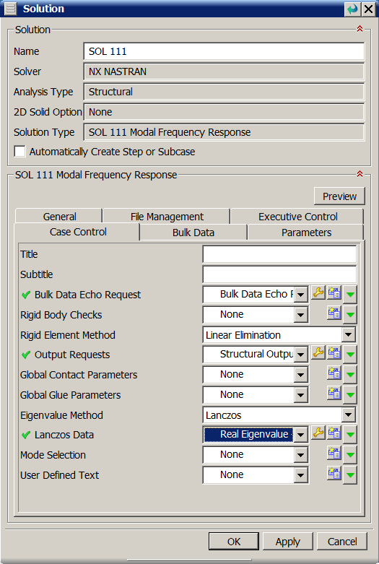  Much of the input is created from the Subcase dialog.  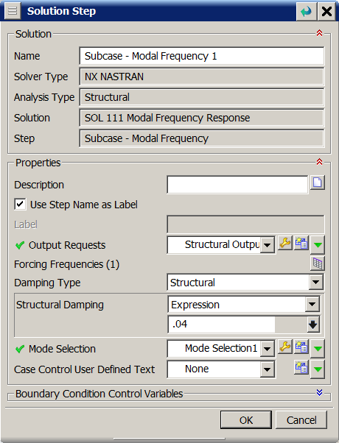 | Run SOL 103 Response Simulation first to get the modes for Response Simulation. The Solution dialog does not have the Eigenvalue Method input. You must edit the Dynamics subcase to define the modes and frequencies  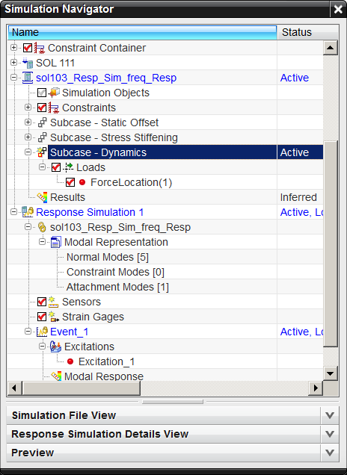  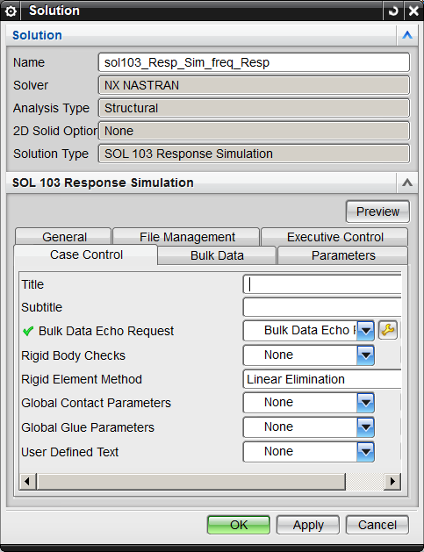

NX SOL 111 Solution Dialogs | Dialogs to run Response Simulation.
Real Eigenvalue dialog  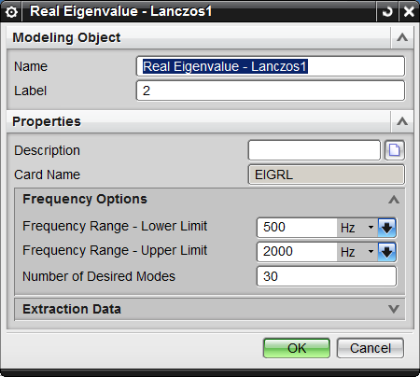 | Edit the Subcase Dynamics in the SOL 103 Response Simulation to input the desired normal modes data.  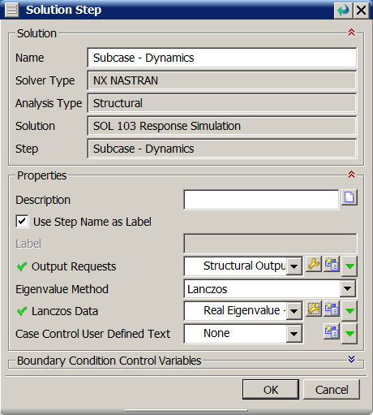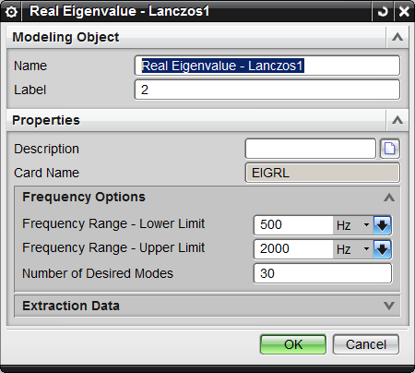

Modes that do not have an impact on the response calculations can be removed from the response portion of the analysis to increase performance of the solution without undue effect on the accuracy of the results.
The Mode Selection Field which allows selection of structural modes and/or fluid modes.  The options Include all modes, Include Specified modes or Exclude specified mode. The NX Nastran MODSEL card is used to specify which mode numbers are to be included in a modal dynamic response solution.  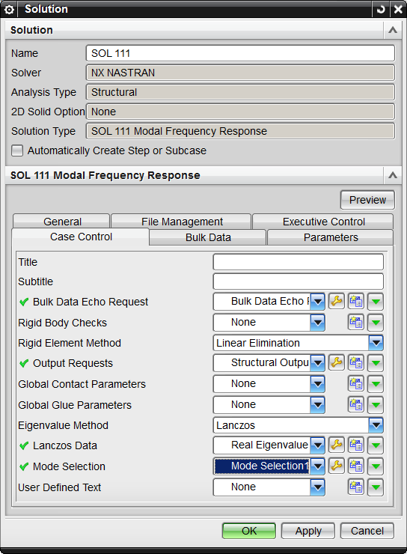  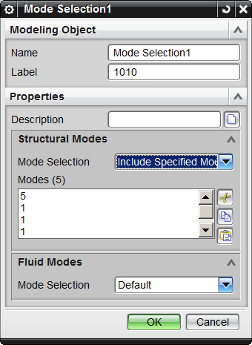 | The modes are activated or deactivated in the Response Simulation Details View. This table is available after a successful SOL 103 with Response Simulation is run and the Response Simulation object is created. RMB on the Normal Modes item under the Modal Representation node, in the Response Simulation node.  LMB / CTL – LMB / Shift – LMB on the desired modes, then RMB to select Activate or Deactivate  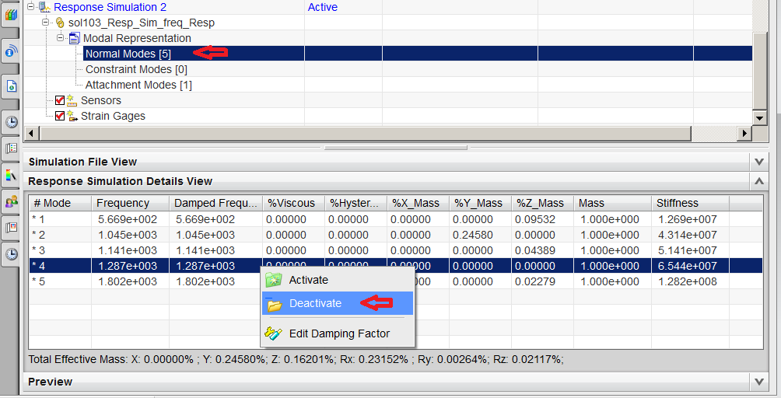
Damping can be added to the NX Nastran analysis by editing the Solution Step / Subcase. Damping Type can be set to Structural Damping, Critical Damping or an amplification Factor. They can be set as a numerical expression or as a frequency based field.  The values are input in NX as real numbers. 4% structural damping is input as .04  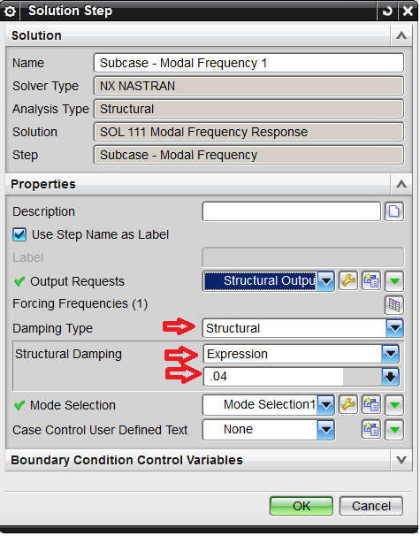 | Damping is set in the table of modes that are displayed in the Response Simulation Details View. This can be done for all at one time or each mode .  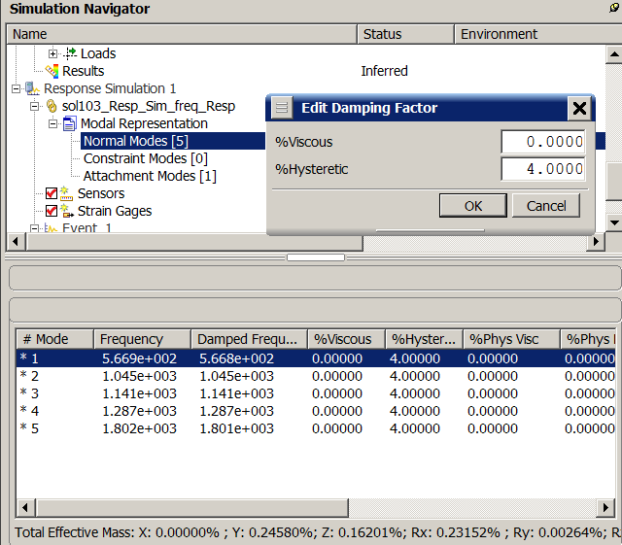  You can apply physical damping and/or user-defined modal damping.  Proportional modal damping is useful for models for which you have no knowledge of physical damping. Response Simulation uses both hysteretic (or structural) and viscous damping in response calculations. Because the modal approach is used in Response Simulation, you can define modal hysteretic and modal viscous damping ratios for each active normal mode. You can also define modal viscous damping ratios by using Rayleigh's damping method, a software option that calculates viscous damping for each mode.
  Note | If you want NX Nastran to calculate physical damping, you must add the appropriate damping elements or material damping in your FEM or define global damping in the G parameter for the solution as described in Damping.  Structural damping is set as hysteretic damping, by RMB on the Normal Modes node under the Response Simulation solution or on the individual mode, Response Simulation Details View. To set 4% Structural Damping for all modes, RMB on Normal Modes and select Edit Damping factor. Key in 4.0 in the %Hsteretic field. Note: the values are input as a percentage value (i.e. 4.0) instead of its decimal equivalent (i.e. .04).  NX Nastran physical damping  For frequency and transient events, you can include in your response evaluations the physical viscous and/or hysteretic damping calculated by NX Nastran.  Physical damping is based on physical and material properties in the NX Nastran model. NX Nastran calculates this damping as part of the normal modes solve. This damping is useful if you know that specific elements or materials in the model have known damping values. For example, you can apply physical damping as viscous damping in a bushing element or structural damping in a material.  To use physical damping, you must first define it in your model before solving for the normal modes.
Create a new Response Simulation by selecting the desired result from a Solution 103 Response Simulation analysis
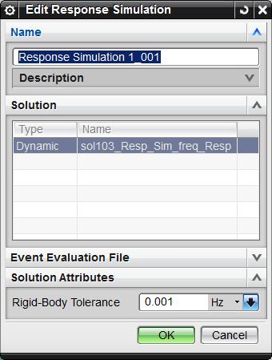
RMB on the active Response Simulation node, in the Simulation Navigator and select New Event.
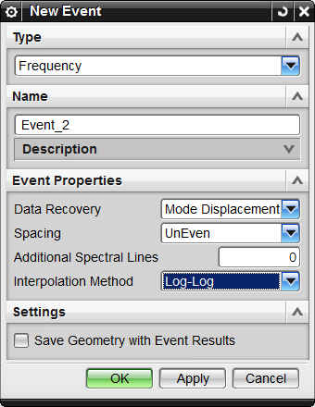
The Mode Displacement Method is the default in  NX Nastran, PARAM, MODACC,-1. If the Mode Acceleration Method is desired, set PARAM, MODACC,0  PARAM, RMSINT specifies the interpolation for numerical integration when computing both RMS and Number of Zero Crossings or Mean Frequency from the PSDF(Power Spectral Density Function)  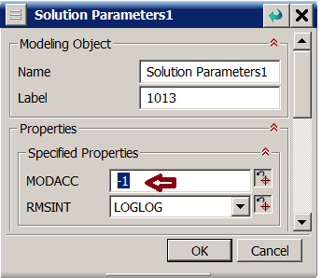 |  | The Mode Displacement or Mode Acceleration Method is selected when creating a new event. It is selected from the Data Recovery dropdown list in the Event Properties group  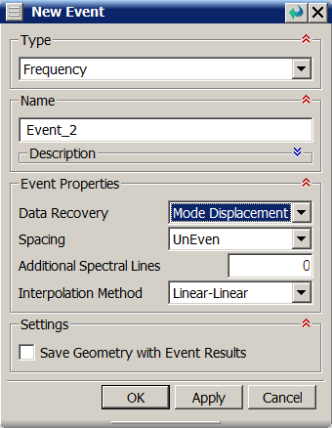

The Freq-Freq(i) cards are the closest input to match Even or uneven excitation and additional spectral lines in Response Simulation.  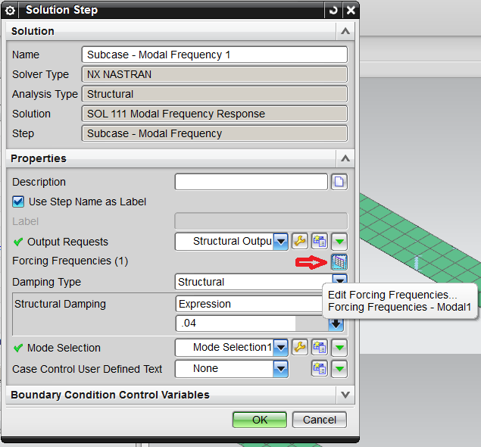  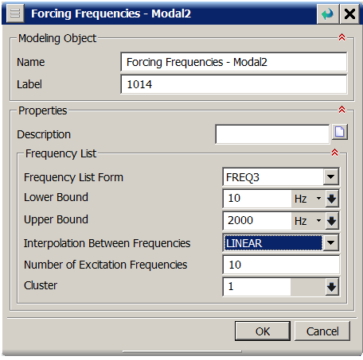 | Additional spectral lines are available only for Frequency and Random events, and only when Spacing is set to Uneven.  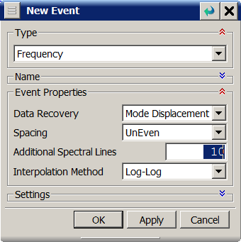  If you are applying uneven excitation functions, and you evaluate the random response at a Range of frequencies (rather than at a selected natural frequency), you can enter a number of extra divisions between modes and excitation frequencies for better resolution in the response function. However, entering a higher value consumes more memory. The default value of 10 is adequate for many situations.
Interpolation between frequencies is available in the FREQ3  Card. | Interopolation method allows selection of the method to approximate Data points when generating Response Functions with addition spectral lines  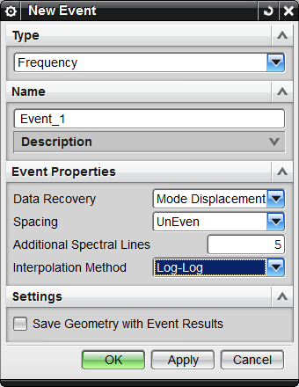

In NX Advanced Simulation, SOL 111 Modal Frequency Response analyis, a Force or enforced motion boundary condition is applied to the subcase. The boundary condition uses a frequency vs. force or a frequency vs. Enforced Acceleration or Enforced Displacement Constraint.  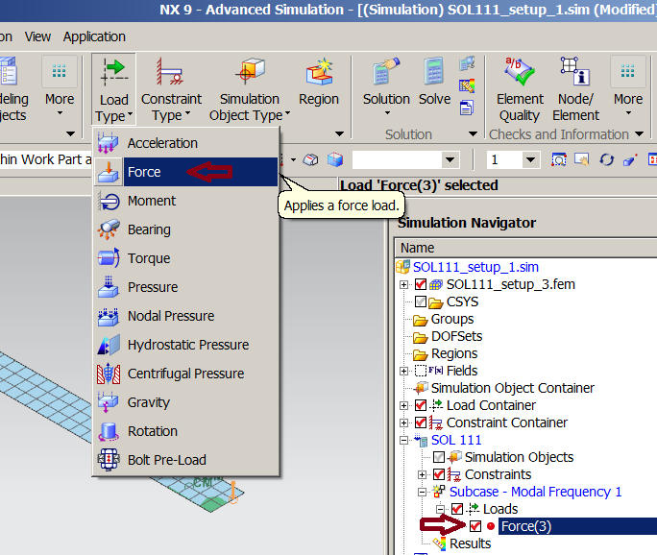 | Response Simulation uses a Nodal Force Location constraint in the SOL 103 Response Simulation analysis as a force placeholder. Enforced Motion is handled with an Enforced Motion Location constraint placeholder.  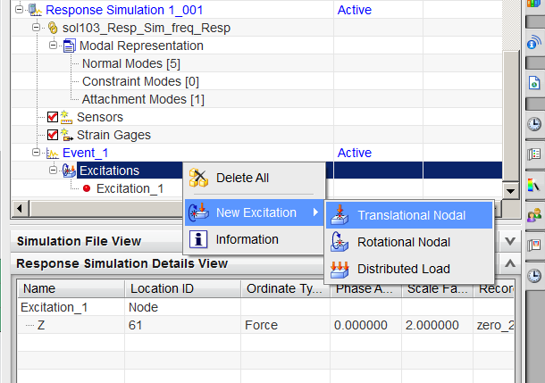
Forcing Funct. 0-200hz incr. 50 hz Amplitude=1 Scale X 2.0 for 2N  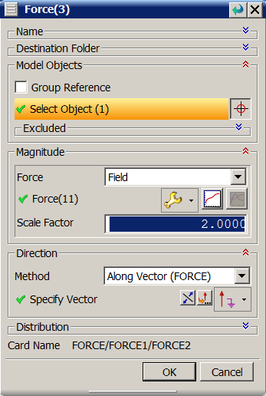 | The Excitation dialog that creates the forcing function is as follows  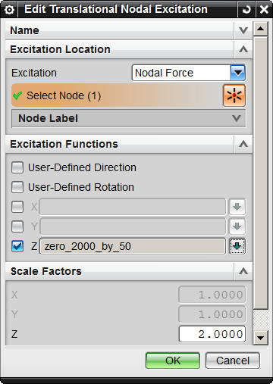

A Frequency vs. Force table is created for the Magnitude field in the Force dialog  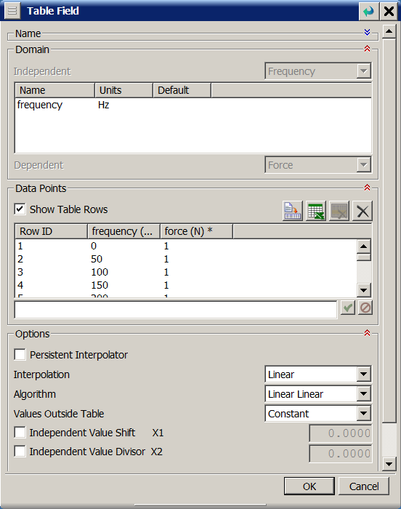 | The XY Function Editor is used to create the excitation function  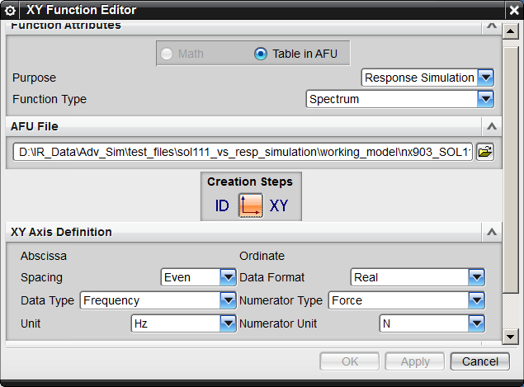

Use Create Graph in the Post Processing Navigator to plot the Nodal Response of a node, such as Displacement 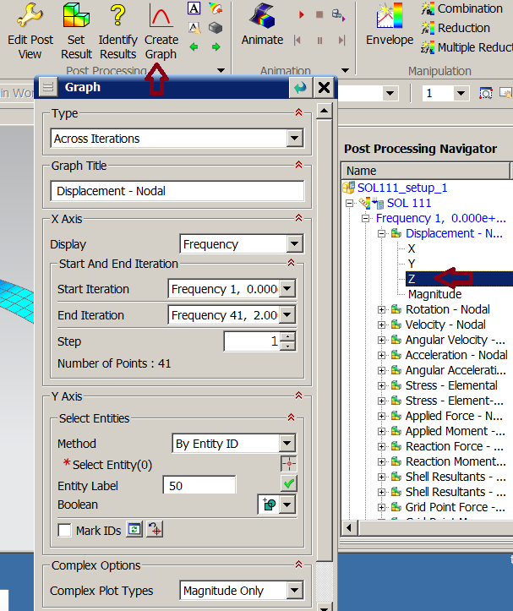 | Select the Evaluate Nodal Functions to plot the response of a node, such as displacement  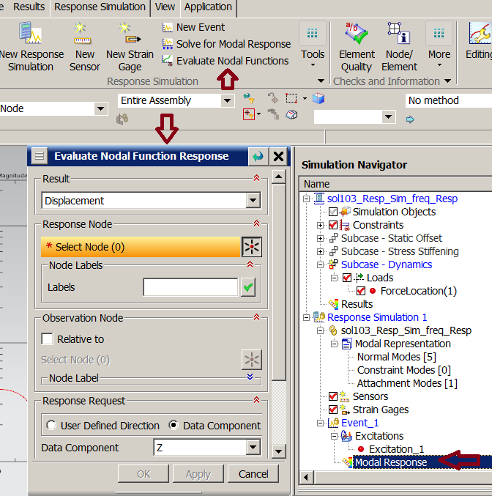

The Resulting plots are from NX 10.0 Advanced Simulation, due to a plotting issue with the SOL 111 result in NX 9.0
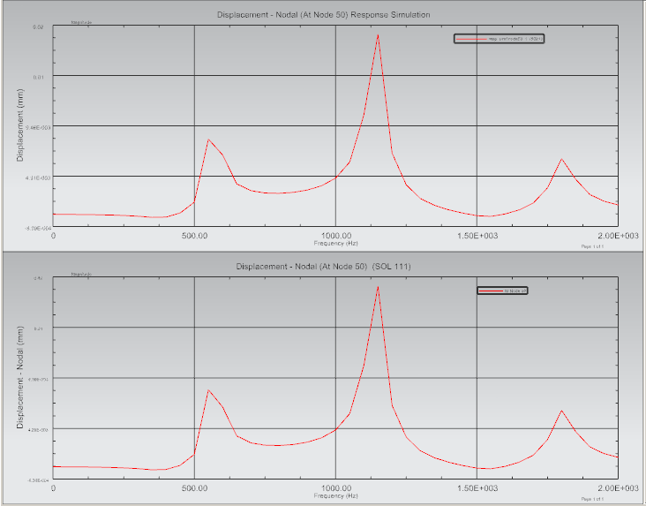
The overlay of the two graphs in NX 10.0 Advanced Simulation


