Restore a previous version of a Solid Edge Dataset

With Solid Edge Embedded Client it is possible to restore an old version of a Solid Edge document if the last document fails or was accidentally modified by a user.
Dataset versions are created when Solid Edge runs in a Teamcenter session. When saving with Solid Embedded Client a new dataset version is created, rather than allowing the software application to overwrite the dataset. Teamcenter continues to manage multiple dataset versions until the version limit is reached. The version limit provides a practical way to specify the maximum number of dataset versions that are stored in the database. Typically there is a default version limit that has been specified by the administrator, using the AE_dataset_default_keep_limit preference. However, you can specify a different version limit for any dataset you create. By default the number of dataset versions is 3 which is the number of versions of datasets Teamcenter keeps before deleting old versions. Changing the value will only affect datasets created after the value is changed.

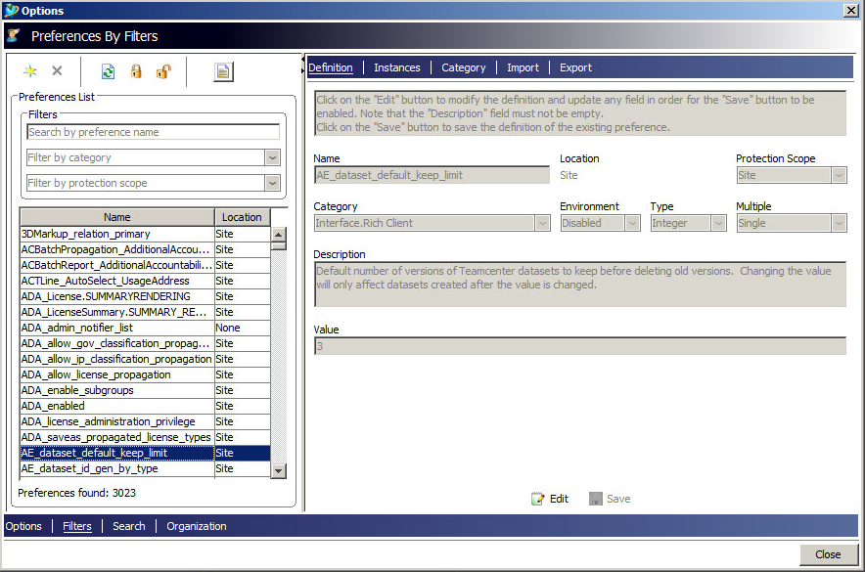

We can examine an example where the user has created a new version of a part, but this one for any reason fails when opening with Solid Edge. The steps below describe how to proceed to restore the « n-1 » version of the part. The same process can be applied for an assembly, a draft, or a sheet metal part.

Search for all dataset versions. Open search view.
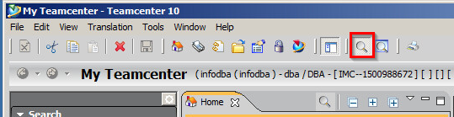

In view menu, open the search options.
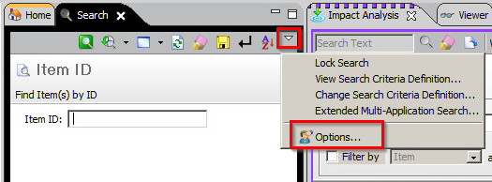

Before running a query verify all the dataset versions will be displayed. Lasted Dataset Versions should be turned off.
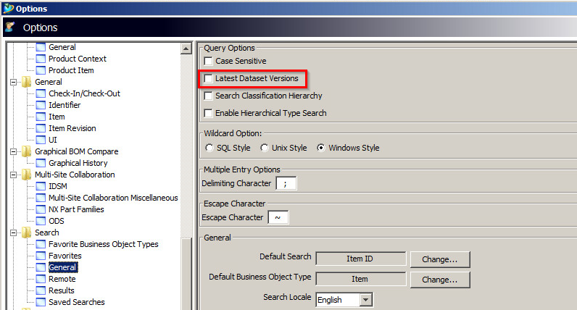

Display all the dataset versions:
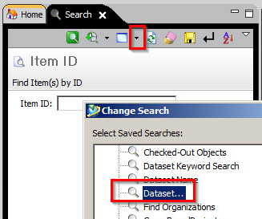

Input the Dataset Name for the part and execute:
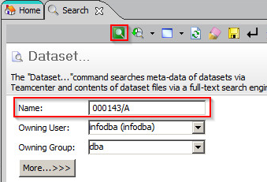

In the results, you will find the 3 different versions
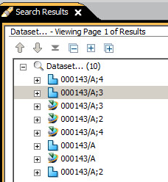

The last version we supposed to be wrong is 000143/A;4 and the version we want to restore is 000143/A;3.
Double click on the wished version 000143/A;3 . You will notice the file is read only. Close Solid Edge and copy your file from the cache Solid Edge which is typically located under %APPDATA%\Unigraphics Solutions\Solid Edge\SEEC to any other folder (e.g. C:\backup), and turn off the read-only attribute.
Another Solution to export the correct version is downloading the named reference in a backup folder:
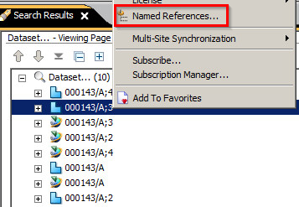
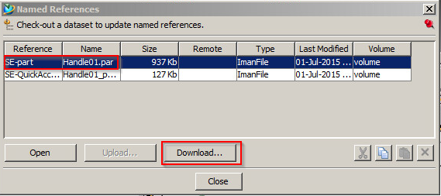
Now, you have to restore this version in Teamcenter. Open the last version 000143/A;4 with Solid Edge. Close Solid Edge, but don’t clean up the cache. Replace in the Solid Edge cache the wrong Solid Edge part by the backup file which is your correct version.
In windows explorer double click on your file. SEEC will open this version in a managed state. Save and upload the document to Teamcenter. You will notice a new version has been created 000143/A;5 and your dataset becomes the latest version.

Michel Santurde.

