Resolving KeyShot Issues after Updating Solid Edge ST10 to Use KeyShot 7

Issue:
Out-of-the-box Solid Edge ST10 comes with KeyShot 6 installed.
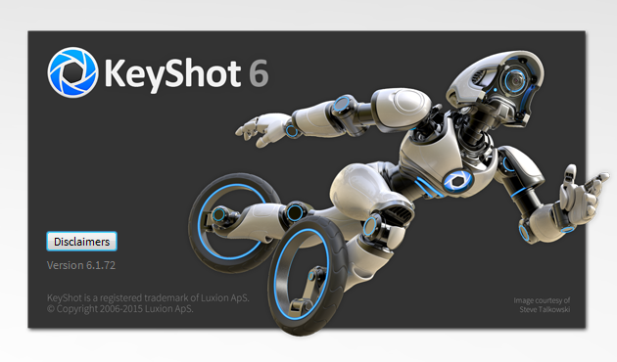
After attempting to update Solid Edge ST10 to use KeyShot 7, KeyShot is running in demonstration license mode only.

Solution:
Use the following instructions to resolve issues with using KeyShot 7 with ST10.
Using "Control Panel" -> "Programs" -> "Uninstall a program", manually uninstall *all* existing versions of KeyShot. In the below screenshot there is both KeyShot 6 and KeyShot 7 installed. We will uninstall both of these versions: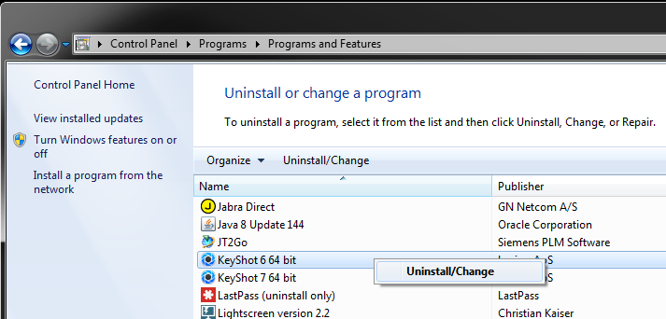
KeyShot 6 being unsintalled:
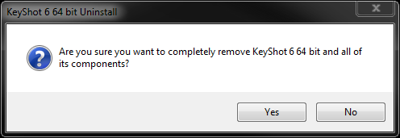
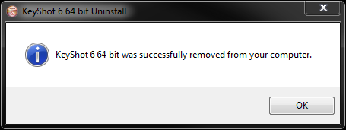
KeyShot 7 being uninstalled:
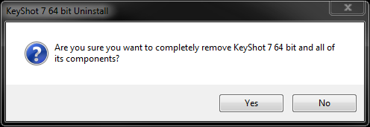
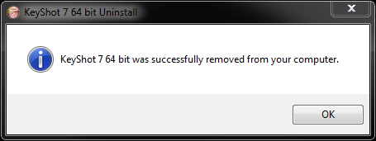

Once all existing versions of KeyShot have been uninstalled, then uninstall Solid Edge ST10:
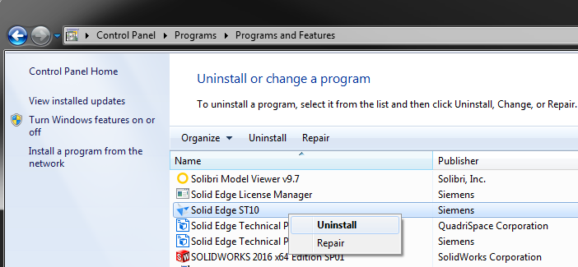
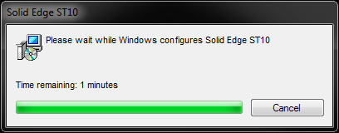
With all versions of KeyShot and Solid Edge uninstalled we must now clean up all related install files and registry entries.

In Windows Explorer browse to and delete the following folder locations, including any files and folders contained under these locations. Note that not all of these locations may exist on your system:
- %APPDATA%\Unigraphics Solutions\Solid Edge
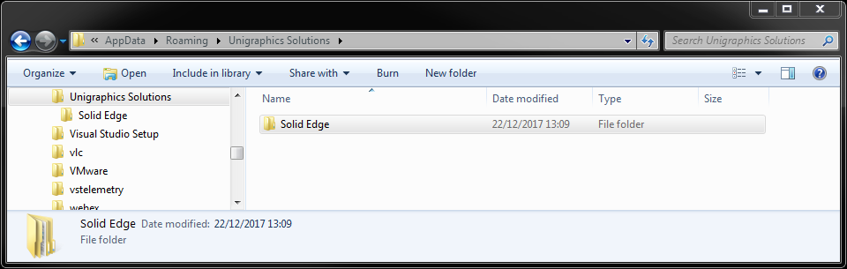
- %USERPROFILE%\AppData\Local\KeyShot <version #>:
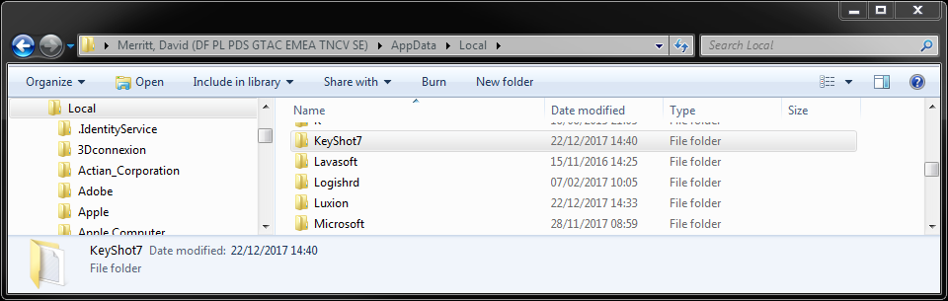

- %USERPROFILE%\AppData\Local\Luxion
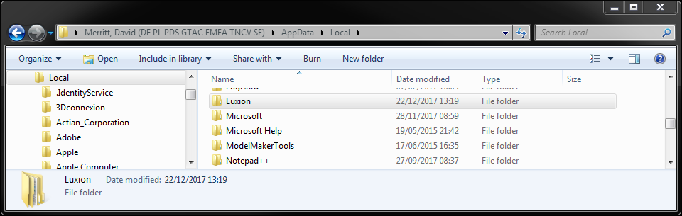
- %Public%\Public Documents\KeyShot <version #>:
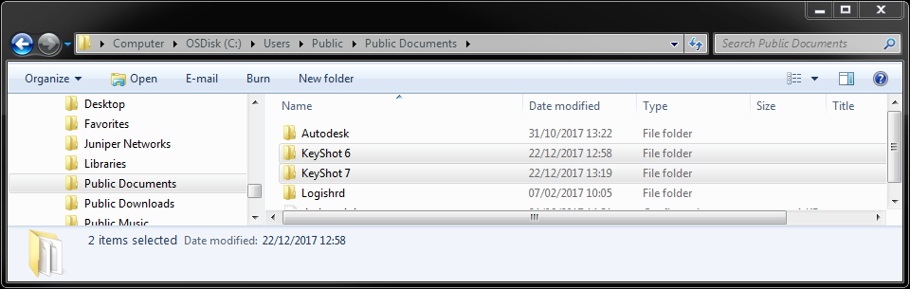

- %ProgramFiles%\KeyShot <version #>:
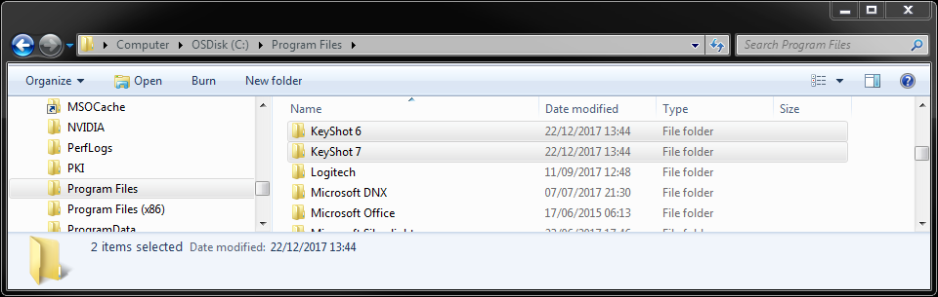
%ProgramFiles%\Solid Edge <version #>:
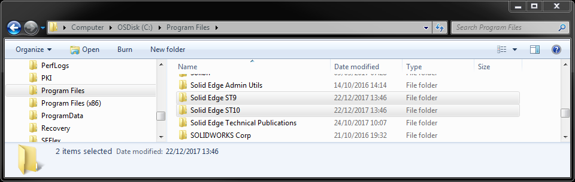

Open a registry editing tool and delete the following registry locations including any keys and entries contained under these locations:
- HKEY_CURRENT_USER\Software\Unigraphics Solutions\Solid Edge
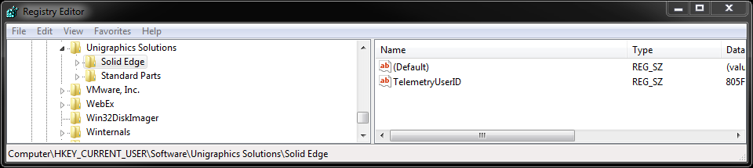
- HKEY_CURRENT_USER\Software\Luxion:
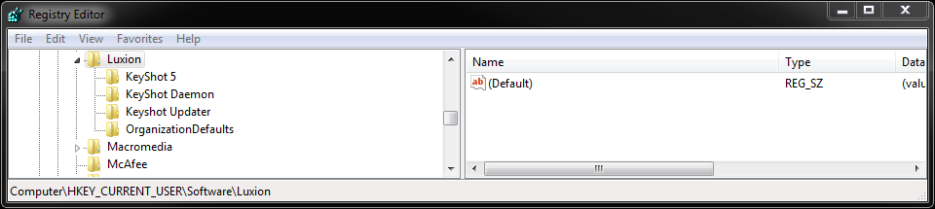
- HKEY_LOCAL_MACHINE\SOFTWARE\Unigraphics Solutions\Solid Edge:
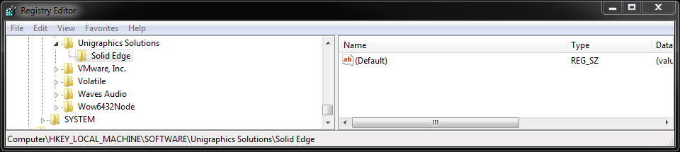

- HKEY_LOCAL_MACHINE\SOFTWARE\Wow6432Node\Unigraphics Solutions\Solid Edge:
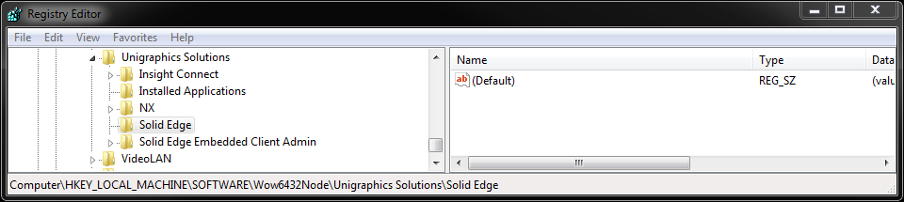
- HKEY_LOCAL_MACHINE\SOFTWARE\Luxion:
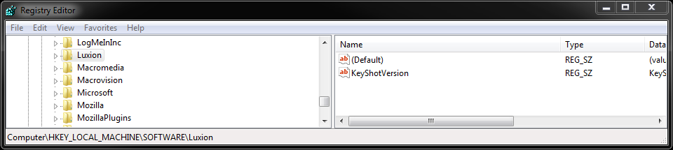
- HKEY_LOCAL_MACHINE\SOFTWARE\Wow6432Node\Luxion:
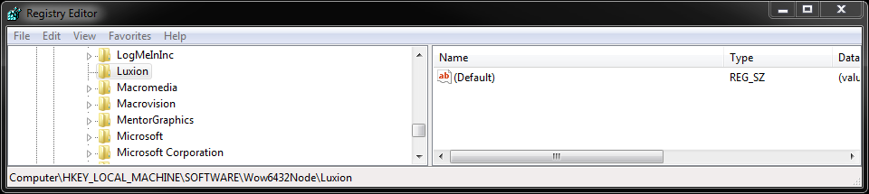

Reinstall ST10 which should automatically reinstall KeyShot 6 as part of the prerequisites:
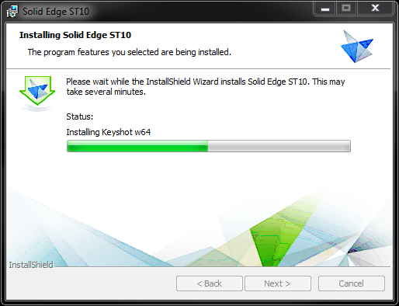
After reinstalling ST10, we need to test our Solid Edge install and ensure that the out-of-the-box KeyShot 6 is properly installed and registered.
Launch Solid Edge and open any model file.
Send the model file to KeyShot Render:
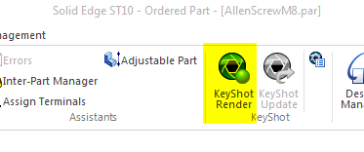
If everything is installed and licensed correctly, “KeyShot 6.1 for Solid Edge” should be installed and running:
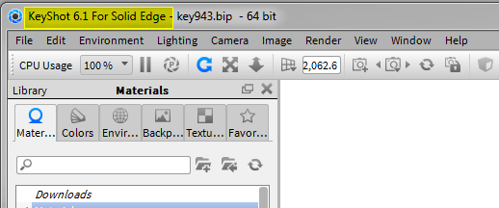
Close and exit the KeyShot and Solid Edge sessions.
Download the latest KeyShot 7 Windows 64-bit version from the following address:
https://www.keyshot.com/?ddownload=335582
Install the downloaded KeyShot 7 by double-clicking on the downloaded install file.
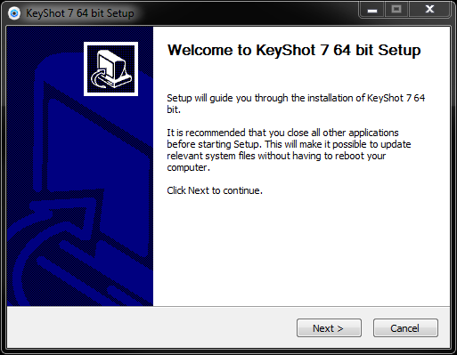

When prompted to “Install just for me” or “Install for anyone using this computer, select “Install for anyone using this computer".
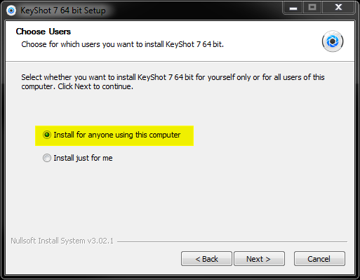
At the remaining install screens, select all of the defaults and finish installing KeyShot 7:
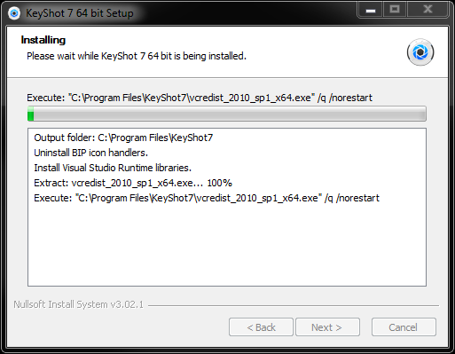

Once successfully installed exit the installer but do *not* run KeyShot 7:
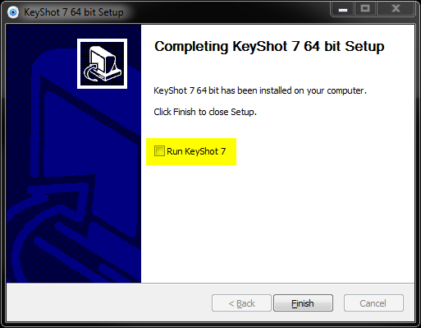
Launch Solid Edge and open any model file.
Send the model file to KeyShot Render:
If everything is installed and licensed correctly, “KeyShot 7.x for Solid Edge” should be installed and running:
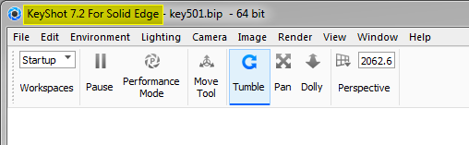
Close and exit the KeyShot and Solid Edge sessions.
Solid Edge ST10 is now ready to use KeyShot 7 and all KeyShot licensing issues should be resolved.
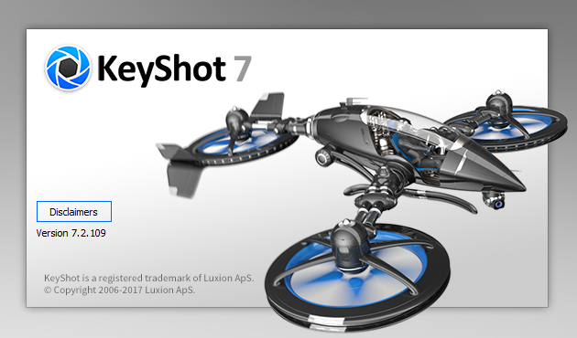

David C. Merritt

