Set Custom Page File Size for Optimum Solid Edge Performance

The Solid Edge readme file states that for optimum Solid Edge performance you should set a custom page file size:
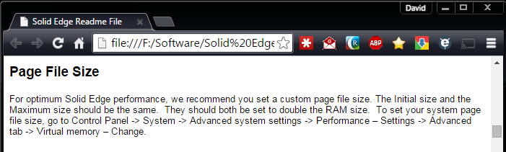

By default Windows is configured to automatically manage the page file size:
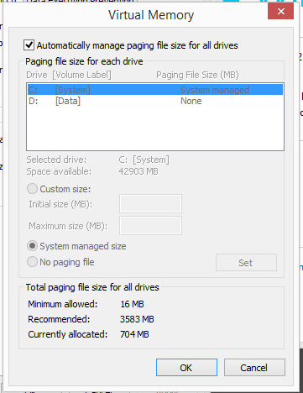

However, this automatic management is neither the optimum setting as recommended for Solid Edge nor is the size the recommended size as reported by Windows. Invariably the page file size is always extremely undersized for both Windows and Solid Edge:

To set the page file size to the recommended optimum size for Solid Edge, open Windows Explorer:
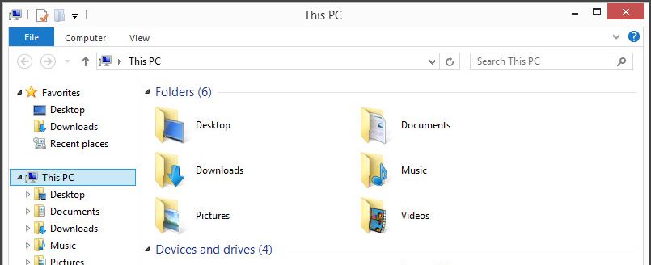

On “My PC” [Note for Windows 7 this is “Computer”] right-click and select “Properties”:
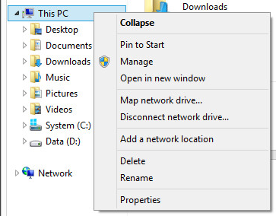

From the “System” window that is opened, note how much RAM is installed on the system. For this example, we have 4 GB RAM showing as installed:
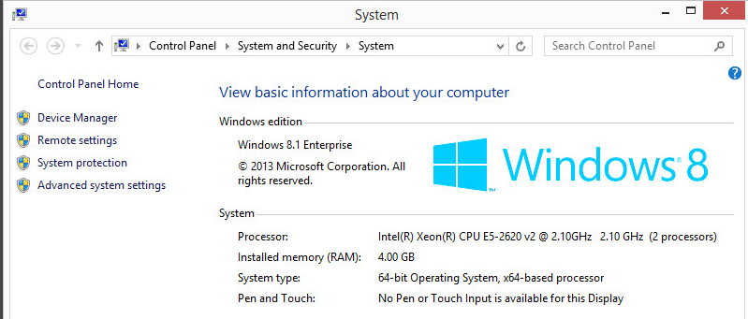

Select “Advanced system settings”:
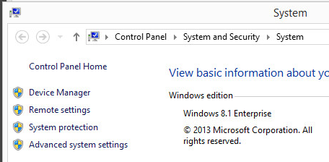

In the “System Properties” window that is opened, select the “Advanced” tab -> “Performance” -> “Settings…”:
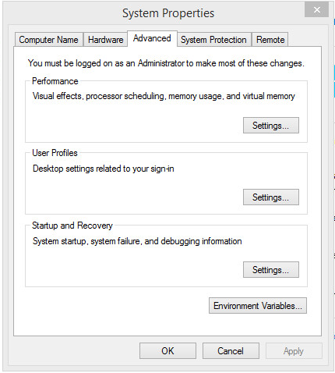

In the “Performance Options” window select the “Advanced” tab -> “Virtual memory” -> “Change…”:
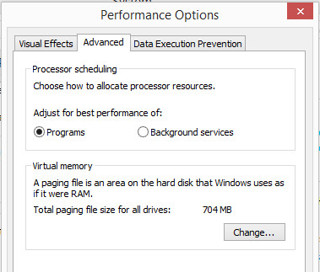

In the “Virtual Memory” window uncheck “Automatically manage paging file size for all drives”:
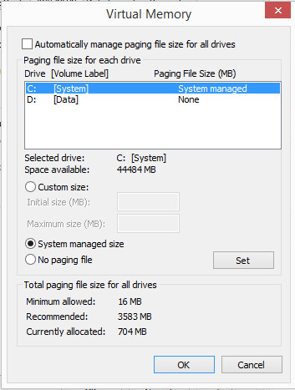

Select “Custom size”:
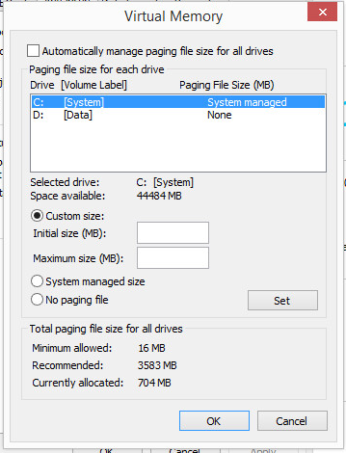

Set both the “Initial size (MB)” and “Maximum size (MB)” fields to the same value. This value will be set to 2 X your installed RAM, where 1 GB equal 1,024 MB:

RAM Installed in GB | Paging File Size in MB
4 | 8,192
8 | 16,384
12 | 24,576
16 | 32,768
20 | 40,960
24 | 49,152
28 | 57,344
32 | 65,536

So for our example used in this document, our system showed 4 GB RAM installed, so we will set our paging file “Initial and “Maximum” size values to “8192”. For your system you will need to calculate the correct sized based on your RAM installed x 2:
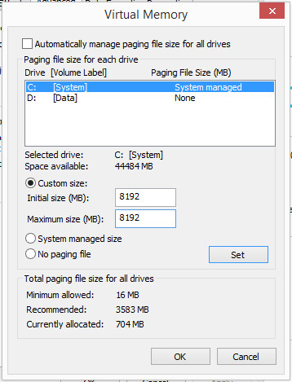

Select “Set” to commit our change made:

Note that the system has now updated to show our specified paging file size:
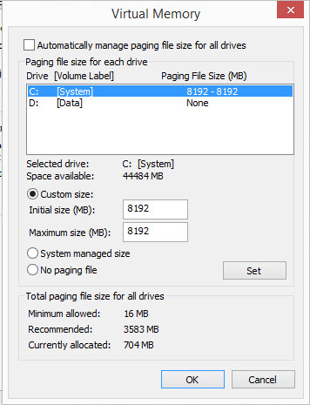

Select “OK” to exit the “Virtual Memory” window:
You will receive a warning that the computer will need to be restarted. Select “OK”:
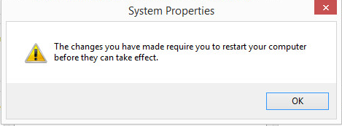

Select “OK” to exit the “Performance Options” window. Note that the page file size is currently still showing our old value:
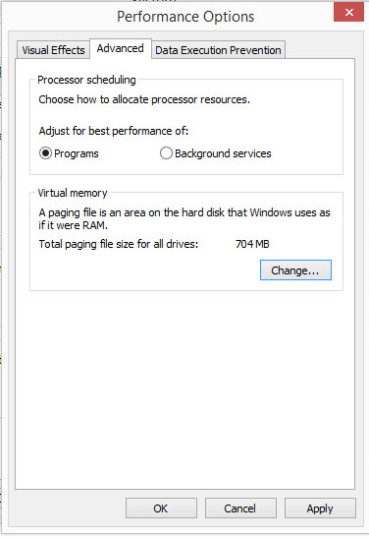

Select “OK” to exit the “System Properties” window:
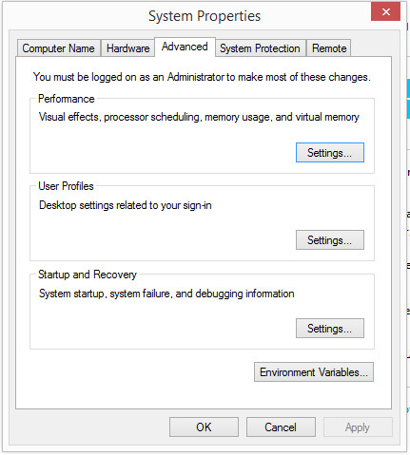

You will be prompted to restart your system. Our updated page file size will not take effect until the workstation is restarted. Select “Restart Now”:
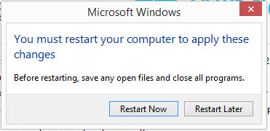

Once the workstation has completed its restart, the paging file size is now correctly set to the recommended 2 X RAM for optimum Solid Edge performance:
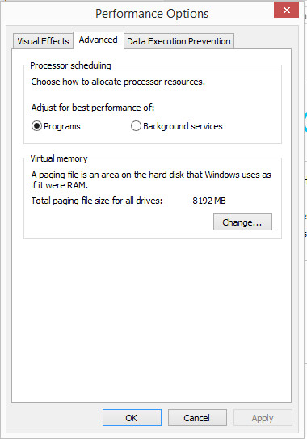

David C. Merritt

